Crystal Harrison's Biography
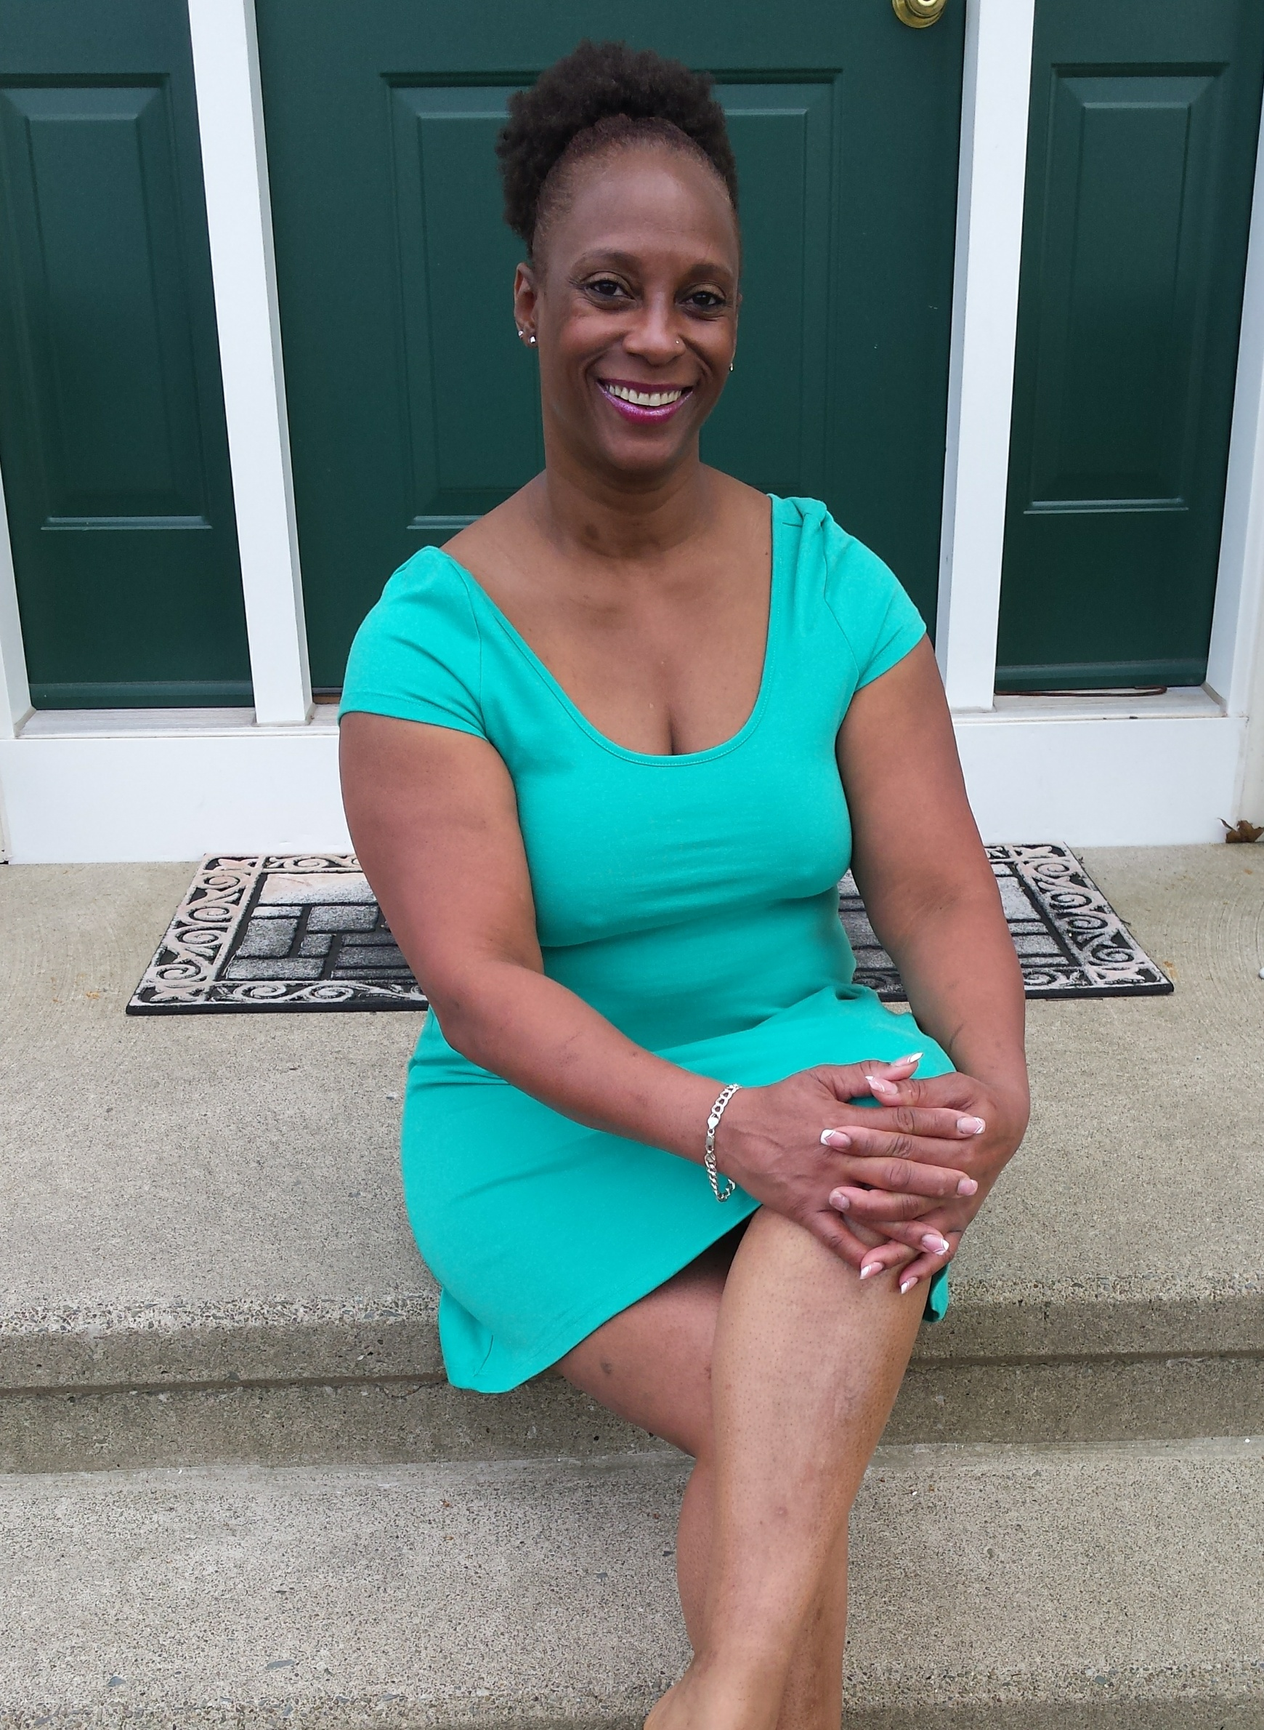
Crystal Harrison is a New Yorker. She studied Afro- Caribbean dance under the late, great LaRoque Bey. She was later chosen to teach as a group instructor, which ultimately lead to membership within the company.
In addition to her tutelage with LaRoque Bey Ms. Harrison studied with renowned artists: Wilhelmina Taylor, Babkunde Olatunje, Bokande, Esther Williams, Nafisa Sharriff, Imani Khan and numerous secular artists. She also studied, instructed and choreographed African, ballet, tap, jazz and modern jazz dance.
Ms. Harrison is a former Rainbow Dancer for the Apollo Theater in New York City. Under the direction of the LaRoque Bey School of Dance and Theater she danced for the opening Gala and Motown Special with Bill Cosby at the Apollo.
In additional to the Apollo, Ms. Harrison performed with the legendary Cab Calloway, Eartha Kitt, Gregory Hines, Debbie Allen and other celebrated figures during her tenure with the LaRoque Bey School of Dance and Theater, Inc.

For more information about Crystal Harrison please visit her Face Book Page: https://www.facebook.com/search/top/?q=crystal%20harrison.

