Daaimah Taalib-Din’s Biography
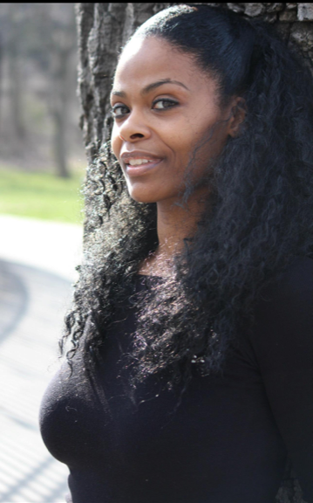
Daaimah’s personal and spiritual relationship to her artistry has made her a most sought-after performer, teacher and choreographer in the United States and abroad. Her gifts earned her the distinction of being the first person to win a Bessie Award (the 2017 award for Best Performer) for African-based dance.
Her music video credits include Black Coffee’s, “Come with Me” in which she was the lead choreographer and Styles P’s, “Never Fight an African” in which she performed her own solo choreography. Daaimah also filmed for the Hollywood production, “Set-Up 3D”.
Daaimah is probably best known for her work in live dance and musical theater, having performed at internationally renowned venues as the New Jersey Performing Arts Center, the Apollo Theater, the Brooklyn Academy of Music, Harlem Stage/Aaron Davis Hall and Black Dance USA.
For more information about Daaimah Taalib-Din please visit her official website: http://www.daaimahtaalibdin.com/

