Dr. Darian Parker’s Biography
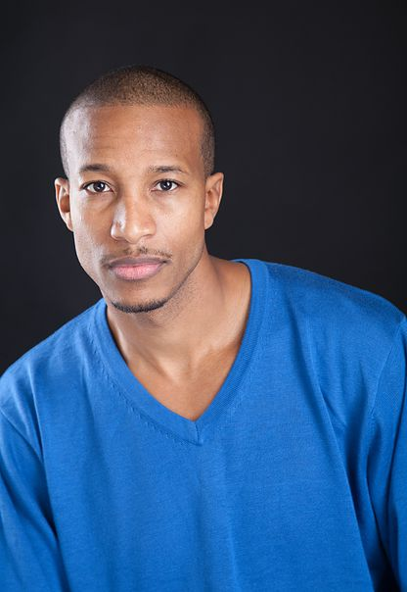
Dr. Darian Marcel Parker was born and raised in Winston-Salem, NC. Florine Parker, Darian’s mother, and the deep vernacular culture of his city instilled a love of African American vernacular music and dance at an early age. As Darian reached adulthood, his love of the African American vernacular expanded to include more styles of the entire African Diaspora. He began studying West African dance at the age of 19 under the incomparable Nzingha Camara. Nzingha taught him that African dance is life. She would say to “never miss your breaks in life”. Just like the break gives us a signal to start, change or stop, so we must listen to the signals that life gives us to either begin something new, change our course, or bring something to an end. Meeting Nzingha was the “break” in Darian’s life to pursue a path of arts and creativity.
Since that fateful meeting, Darian has continued to travel to West Africa and throughout the US to study Guinean, Malian, Casamance and Ghanaian dance styles. He has performed internationally with a number of dance companies, including Les Ballets Kouman Kele (Nzingha Camara), Kouffin Keneke (Aly Tatchol Camara), Harambee Dance Company (Sandella Malloy) and Sewee African Dance Company (Mouminatou Camara) and Organic Magnetics (Maija Garcia). His show credits include the Hollywood film Step-Up 3D, the Fats Waller National Tour, G’Bassikolo Mexican Tour, and Dance Africa (New York and Chicago). Some of his teachers include Mareme Faye, Malang Bayo, Aly Tatchol Camara, Marie Basse-Wiles, Sandella Malloy, Esther Grant-Walker, Nafisa Shariff, Mouminatou Camara, Ismael Kouyate, Ousmane Sall, Ibrahim Doumbia, Wilhelmina Taylor, Micki Davidson and Isaac Akrong. His choreography and teaching have earned him grants and awards from the Harlem Stage Fund for New Work, the Jerome Foundation and the New Haven Arts Council. As a teacher, he has completed a number of residencies at such institutions as SUNY Purchase’s Dance Department and served on the faculties of the Harlem School of the Arts, Forces of Nature Youth Arts Academy, Dwana Smallwood Performing Arts Center, and Cumbe Center for African and Diaspora Dance, among others. Whether teaching students or working with professional dance artists, he always aims to instill a sense of passion for discovery and experimentation.
Dr. Parker carries this same passion into his intellectual pursuits, particularly of the “big questions” of human existence, cutting across several disciplines—astrophysics, anthropology, philosophy and mathematics, among others. His engagement with these questions is what inspires him to foster a sense of intellectual curiosity in others, as an entrepreneur, educator and author. In 2015, he founded Parker Academics, a Manhattan-based test preparation and tutoring company that takes a “whole-person” approach to learning. He is also the author of Sartre and No Child Left Behind: An Existential Psychoanalytic Anthropology of Urban Schooling (Rowman and Littlefield, 2015), and “The Haze”, which appears in Pedagogies in the Flesh: Case Studies on the Embodiment of Sociocultural Difference in Education (Palgrave Macmillan, 2017). Dr. Parker currently serves as the editor of Rowman and Littlefield’s Anthropology and Education series and is an adjunct professor in New York University’s Division of Applied Undergraduate Studies.
In 2017, Dr. Parker joined the board of Y-Apply, a nonprofit that identifies talented public-school students from diverse backgrounds and assists them in their applications to top-tier colleges and universities. In addition, he maintains active membership in Ivy Life, the American Anthropological Association, the Amateur Astronomers Association of New York, the Society for Phenomenological and Existential Philosophy, and the Yale University Alumni Association; for the latter, he acts as an interviewer for prospective undergraduates. Dr. Parker graduated from Yale University with his PhD, M. Phil and MA in anthropology and African American Studies, and cum laude from UCLA’s College of Honors with BA degrees in English literature (departmental highest honors) and anthropology.
For more information about Dr. Darian Parker please visit his official website: http://www.parkeracademics.com/

